Product Design

Project: Focal
Team: 5

Team Member Names: Elisa Arbaiza, Madison Dean, Lily Hillman,
Diego Villela Morua, Jacob Whittington

Revision

Revision Number | Revision Date | Summary of Changes | Author(s)
1 | 09/18/2026 | Created the document with revisions. | Elisa A.
2 | 09/23/2026 | Created a rough Class Diagram and ER Diagram | Jacob W.
3 | 09/23/2026 | Created a rough Information Architecture Diagram | Diego V.
4 | 09/24/2026 | Added Design Summary and Design Rationale | Lily H.
5 | 10/1/2026 | Updated Class Diagram with descriptions and added annotations to more screens | Jacob W.

Class Diagram
User - This class will store the information of each user. Each user will have the variables user id, email, password, and username. Each user will have the function to upload artwork, create inspiration boards, and create comments.
Artwork - This class stores the information about artwork that a user has uploaded. Each piece of artwork will have an artwork id, artist id (related to the user), a title, and private (to signify if the art is public or private). The artwork will be able to fetch the comments posted to it and set a caption about the artwork.
Inspiration Board - This class stores the information about the board a user has created that holds the artwork. Each board will have a board id, an owner (related to the user), and a name. The board will have the capabilities to save and remove artwork from the board.
Revision - This class holds information based on what revisions have been made to the artwork. The revisions will contain a revision id and the id of the artwork that is being revised. This class will be able to set the revision that is current and retrieve this revision number.
Comment - This class is how users will be able to give recommendations about their art. Comments will have an id, be tied to an artwork’s revision, have an author id (tied to the user), and have a body of text (what is readable). Comments will be able to get set and users will be able to reply to other user’s comments.
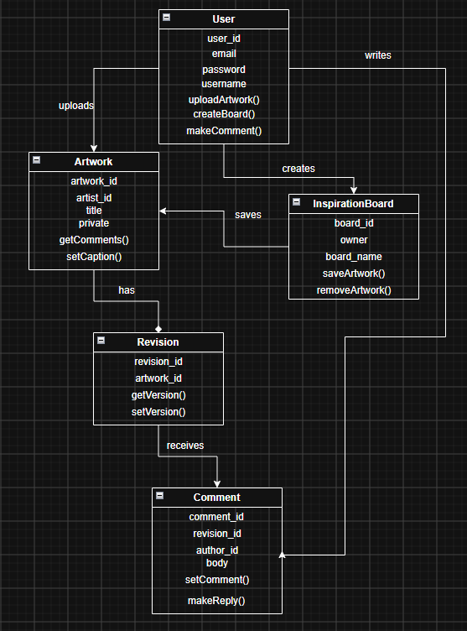

ER Diagram
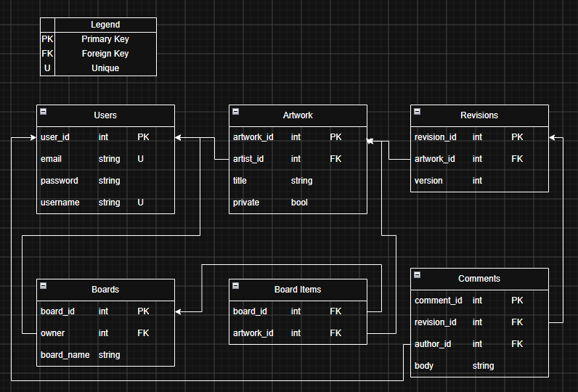

Information Architecture Diagram
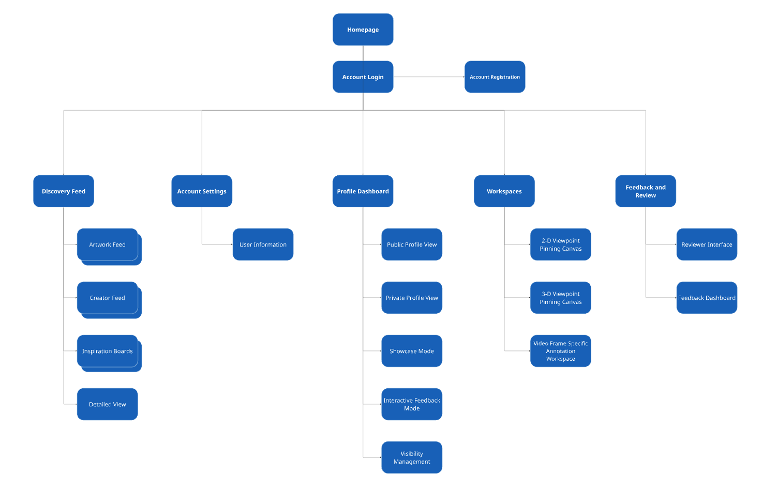

User Interface Wireframe

Color: Potential color palette for the website.

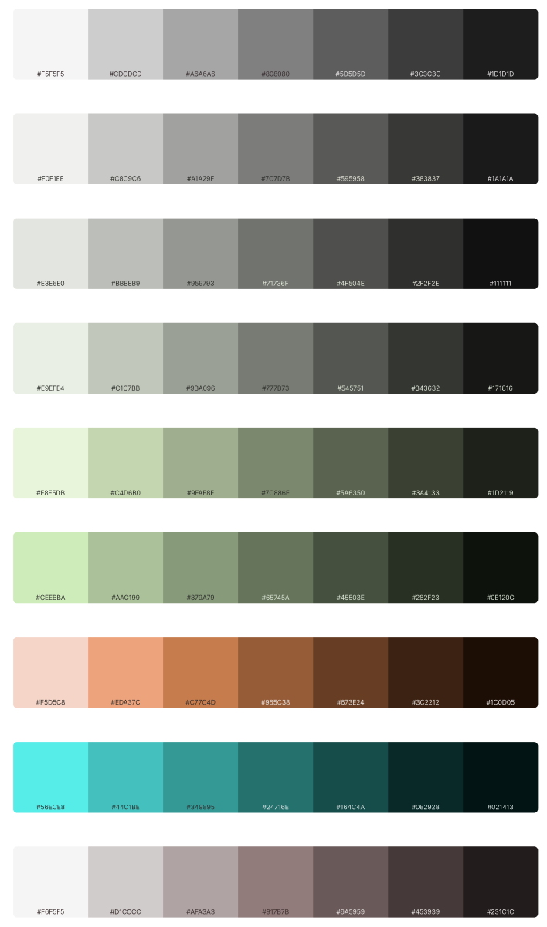

SCR-01 - Inspiration Discovery Feed
The main exploration hub where users can browse work from creators and categorize by medium. Users will be able to search for artwork, creators, etc.

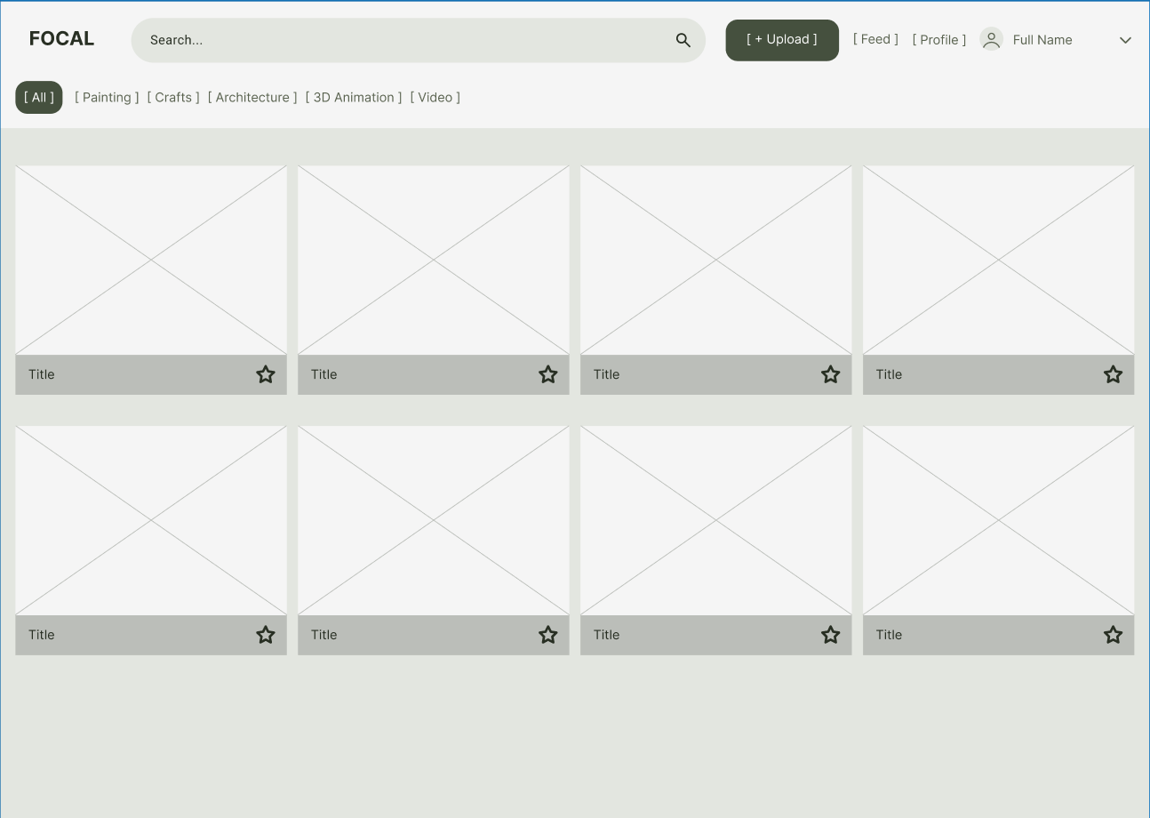

SCR-02 - Creator Portfolio & Profile View
The creator’s public and private profile, which features the showcase clean mode and the interactive feedback mode, and visibility management.

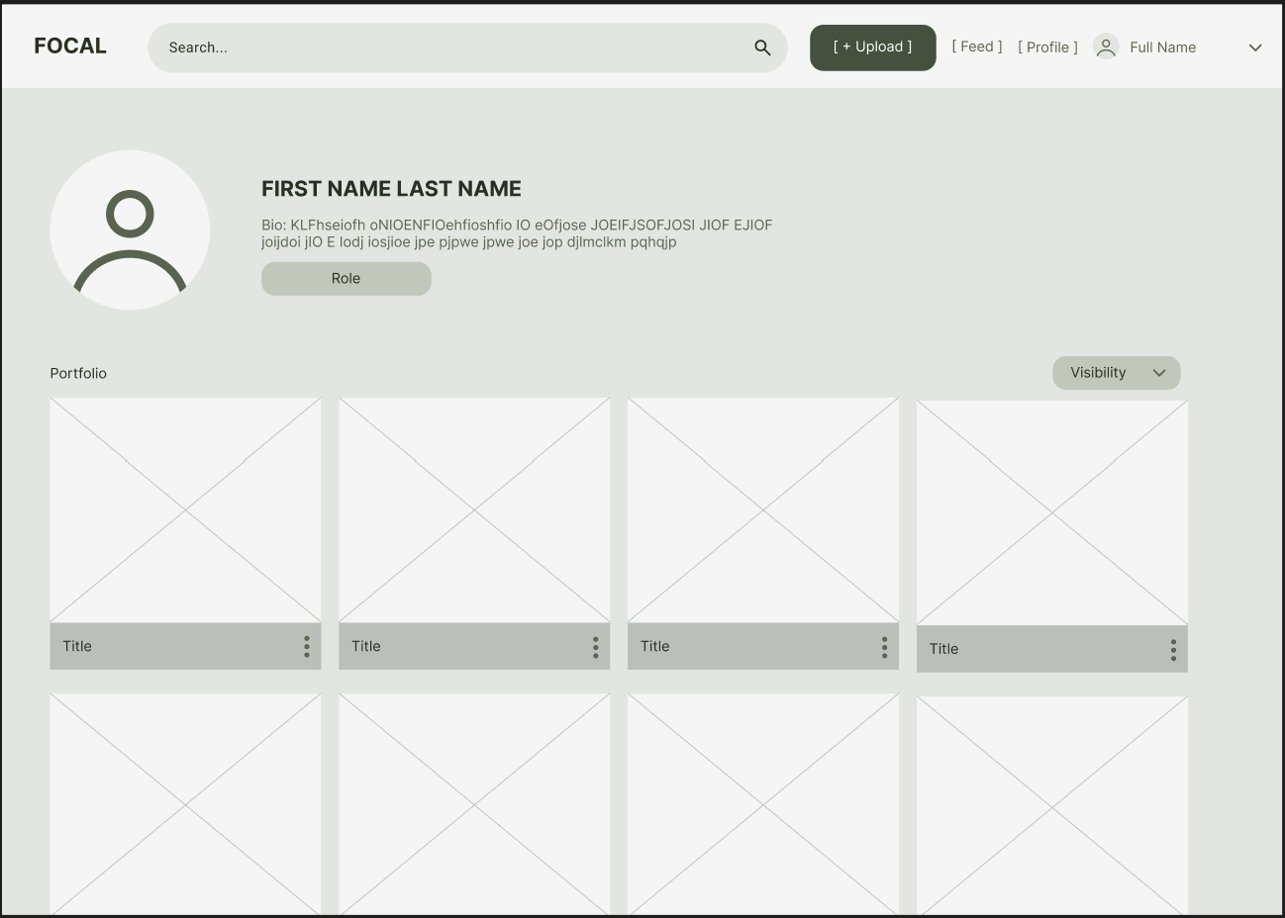

SCR-03 - Inspiration Boards Management & Detail View
The board workspace for feature F8 where users can create, organize, and view collections of saved uploads across various media.

SCR-04 - User Registration (Signup)
The screen that allows new users to create an account by providing basic identifying details and choosing a creative role identifier.

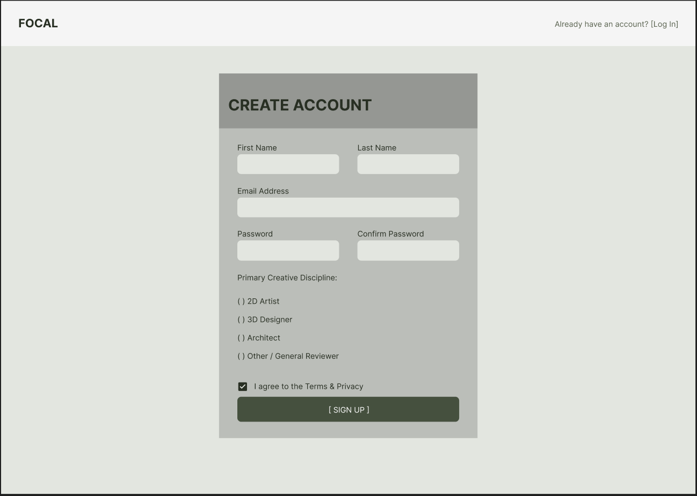

SCR-05 - User Authentication (Login)
The secure authentication interface where existing users can log in with their email and password.

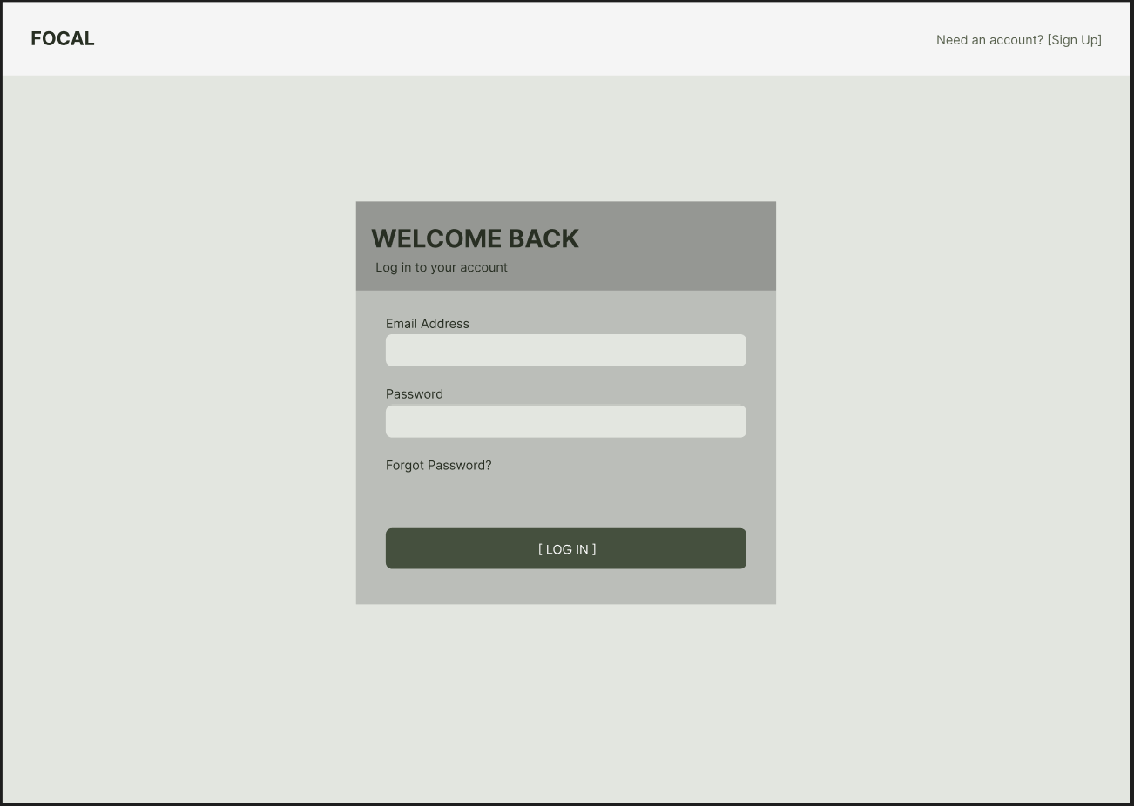

SCR-06 - 2D Viewpoint Pinning Canvas
The 2D inspection workspace where reviewers can drop a coordinate (X, Y) pin in two-dimensional space.

SCR-07 - 3D Viewpoint Pinning Canvas
The 3D inspection workspace where reviewers can move on a mesh surface to drop a coordinate (X, Y, Z) pin in three-dimensional space.

SCR-08 - Frame-Specific Video Annotation Workspace
The timeline and video player interface that will allow reviewers to navigate frame-by-frame using keyboard shortcuts and drop feedback directly to paused video frames.

SCR-09 - Reviewer Resolution & Feedback Management Dashboard
The reviewer interface for tracking given critiques, monitoring artist revisions, and marking items as resolved, bumped, or ignored.

Design Summary
Our design will include multiple easy to maneuver pages within the web app that users will be able to click through to get to where they need. These will include a main hub for “Inspiration Discovery” that will allow users to browse through content similar to the categories that they enjoy, a “Creator View” that will allow the user to view their own content, and will hold notifications for any feedback they’ve received, an “Inspiration Board Management” page which will allow the user to organize and edit what art they have uploaded. These pages contain the fundamental basis for which our web app will run. Other pages will include a registration page, a login page, and multiple feedback pages tailored specifically to the type of content feedback is being given on.

Design Rationale
The design for all Focal pages will be intentionally curated to work for artists and their workflows. Artist feedback is at the heart of the Focal project, and is what makes this project unique. The 2d, 3d and frame specific pinning pages will allow users giving feedback to place pins and annotate their opinion on how to improve the piece of art they are critiquing, while making it abundantly clear where the perceived problem lies, rather than leaving the artist to guess. These changes to the classical critiquing method will allow users to more effectively implement feedback, giving them the opportunity to improve the quality of their work without sacrificing the chance to learn along the way.
The inspiration discovery feed will be designed in a way that fosters the growth and passion of all artists that use it. Artists will be able to set preferential tags to content that they enjoy, as well as tagging their own art to allow like-minded users to find that content. For example, a potter likely enjoys and wants to see more pottery, but they also enjoy the series “Game of Thrones”. They can select these tags in their preferences, and will be catered to these categories when going to the inspiration discovery page.

